Phonics Actions

This booklet contains the actions that we teach in our phonics sessions. Each picture/action links to a phoneme (sound).
We find that having an action to match the sound helps children to remember the sound and also which letter or letters are used when writing the sound.
At first, the emphasis is on hearing, reading and recognising the sounds.
We then move on to writing the letters to match the sounds.
The phases relate to the order we teach phonics, following the ‘Letters and Sounds’ programme.

s | 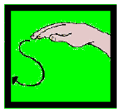 | Weave hand like a snake, making s shapes while saying ssssss.
a | 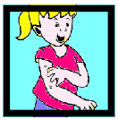 | Short a: Wiggle fingers above  elbow, as if ants are crawling on you, and say a,a,a.
t | 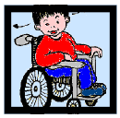 | Children imitate watching tennis, moving head side to side saying t,t,t.
p | 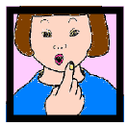 | Hold up index finger, pretending it is a lit candle, and imagine you are blowing it out by saying p,p,p.
i | 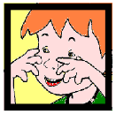 | Children pretend to be mice by wiggling fingers on the end of their noses and squeaking i,i,i, i.
n | 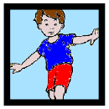 | Hold out your arms, as if you are a plane nose diving, and say nnnnnn.
m | 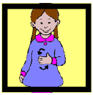 | Rub tummy, as if you see tasty food, and say mmmmm.
Phase 2
d | 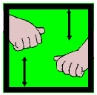 | Pretend to hold drumsticks and beat up and down saying d,d,d.
g | 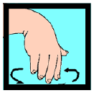 | Spiral hand down, as if water  gurgling down a plughole, saying g,g,g.
o | 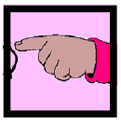 | Short o: Pretend you are turning a switch on and off, saying o,o,o.
c/k | 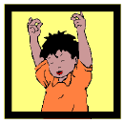 | Raise hands and snap fingers, as if playing castanets, saying k,k,k.
u | 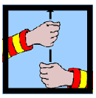 | Short u: Keep one hand steady and raise the other up, as if raising an umbrella, saying u,u,u.
e | 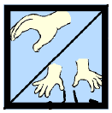 | Short e: Pretend to hold egg in two hands and crack it open. Say eh, eh,eh.
r | 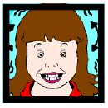 | Pretend to be a puppy pulling a rag in its teeth. Keep teeth closed, shake head and say rrrrr.
h | 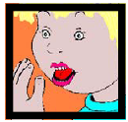 | Act as if panting after a race: hold hand to mouth and say h,h,h.
b | 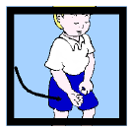 | Place hands together , as if batting away a cricket ball, and say b,b,b.
f | 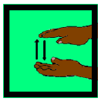 | Place one hand above the other and push them together gently, as if a toy fish is deflating, saying fffff.
ff |  | Like ‘f’. Outstretch arms to show longer sound.
l | 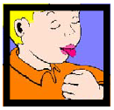 | Pretend to lick a lollipop, saying lllll.
ll |  | Pretend to lick a lollipop, saying lllll. Outstretch arms to show longer sound.
ss |  | ‘S’ like for ‘snake’. Extend arms to show longer sound.

Phase 3
j | 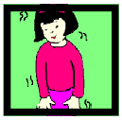 | Pretend to be a jelly and wobble, saying j,j,j.
v | 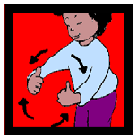 | Pretend to be driving along in a van saying vvvvv.
w | 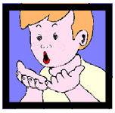 | Blow into open hand, like the wind, saying wh,wh,wh.
x | 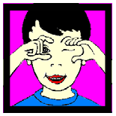 | Imagine you are taking an x-ray with an x-ray gun in your hand. Move hands up and down and say ks,ks,ks.
y | 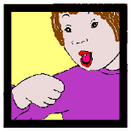 | Pretend to eat yoghurt from a spoon, saying y,y,y.
z | 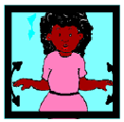 | Pretend to be a buzzing bee, with elbows in and arms flapping while saying zzzzzzzzzzzz.
zz |  | As for ‘z’. Outstretch arms to show longer sound.
qu | 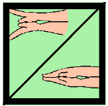 | Make a duck’s beak with your hand and say qu,qu,qu.
sh | 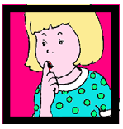 | Put your index finger over your lips and say shshsh.
th | 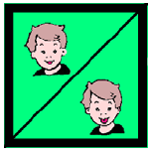 | Hard and soft th: Pretend to be a naughty clown and stick tongue out a little for th (as in this) and a bit further for th (as in thumb).
ch | 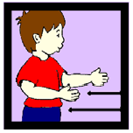 | Pretend you are an old fashioned train moving your arms back and forth while saying ch,ch,ch.
ng | 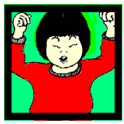 | Pretend to be a weightlifter, lifting a heavy weight above your head, and say ng………
ai | 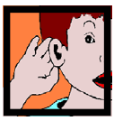 | Long a: Cup hand over ear, as if hard of hearing, and say ai,ai,ai.
ee/  or | 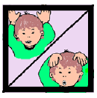 | Put hands on ears and pretend to be a donkey, saying eeee-or, eeee-or.
oo | 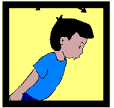 | Short and long oo: Imagine being the cuckoo in the cuckoo clock, bending forwards and back while saying u,oo, u,oo.
oa | 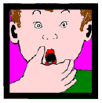 | Long o: Hold hand over mouth, as if you have done something wrong and say oh!
ar | 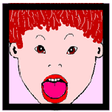 | Open mouth wide and say ah…
igh | 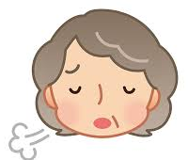 | Sigh. Shoulders down. Say igh, igh (like the word ‘eye’).
ur | 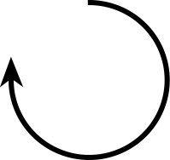 | Big turn in the air (make a large circle) with arm. Say ur, ur, ur.
ow |  | Make cow horn actions. Say ow (like in cow).
oi | 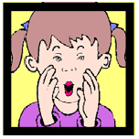 | Cup hands around mouth and shout to a boat, saying oi! Ship ahoy!
ear | 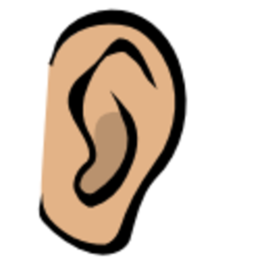 | Point to ear. We hear with our ear. Say ear, ear, ear.
er | 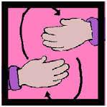 | Roll hands over like a food mixer and say er, er, er.
air | 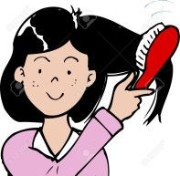 | Brush hair. Say air, air, air.
ure | 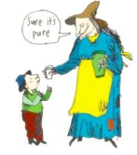 | ‘Sure it’s pure?’ Shrug arms. Say ure, ure, ure (like the word ‘your’).
nk |  | Touch chin as if think ing.
Phase 5
ay |  | New day. Hands spread.  These letters are often found at the end of words, eg ‘day’, ‘play’. Say ay, ay, ay.
ou | 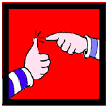 | Pretend your finger is a needle and prick your thumb, saying ou,ou,ou.  Like in the word ‘ouch’.
ie | 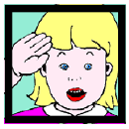 | Stand to attention and salute saying aye, aye (like the word ‘eye’).
ea | 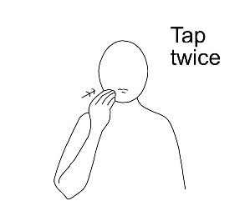 | Long ‘ea’ sound. Makaton sign for ‘eat’. One hand, finger tips clenched, touch lips.  Say ee, ee, ee like in the word ‘eat’.
oy | 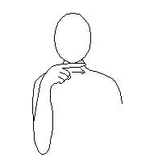 | Makaton sign for ‘boy’. Point across under chin.  The letters used for this sound often come at the end of a word, like in ‘boy’, ‘toy’ and ‘enjoy’. Say oy, oy, oy.
ir |  | ‘First’. Hold up index finger.  Like in the words, ‘first’, ‘bird’, ‘third’. (There are 3 different letter combinations to make this sound).
ue | 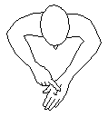 | Makaton ‘blue’. Run finger down blue vein on other hand. Say oo,oo,oo. Like in the words ‘blue’, glue and true.
aw | 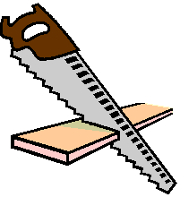 | Make a sawing action ‘saw’. Say or, or, or ; like in the words ‘saw’, ‘claw’ and ‘draw’.
wh |  | Makaton sign for ‘where’ (arms circling to the sides). Say w, w, w like in the words ‘wheel’, ‘whisper’, ‘why’.
ph |  | Pretend to take a photo. Say f, f, f like in the words ‘photograph’, ‘dolphin’.
ew |  | Chew the stew. Make chewing action and say oo, oo, oo like in ‘flew’
ue | 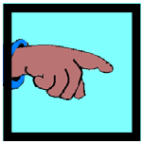 | Point to people around you and say you, you, you. Like in the word ‘rescue’.
oe | 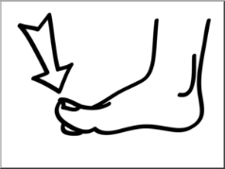 | Point to toe. Say oh, oh  like in the words ‘toe’ and ‘Joe’.

au |  | Autumn leaves. Gently sway hands down as if autumn leaves are falling. Say or, or, or, like in ‘autumn’, ‘haunted’ and ‘sauce’.
ey | 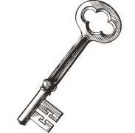 | Long ‘ee’. Turn hand as if turning a key in a lock. Say ee, ee, ee like in the words ‘key’, ‘journey’ and ‘chimney’.
a-e | 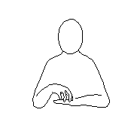 | Makaton sign for cake (hand in cake shape on top of other hand). Say ‘Make a cake’.  Like in the words ‘wake’, ‘flame’, ‘ape’.
e-e | P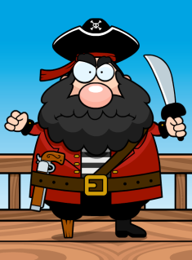 | Pete the Pirate. Put one hand over one eye like an eye patch. Say ee, ee, ee like in ‘Pete, ‘athlete’ and ‘extreme’ (not a common way of making this sound).
i-e | 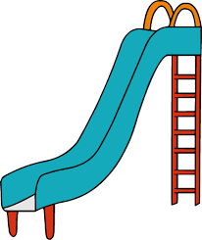 | Slide action made with hand. Like in the words ‘slide’, ‘size’, ‘time’.
o-e | 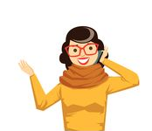 | Say ‘Phone home’. Hold a pretend phone to ears.  Like in the words ‘phone’, ‘bone’, ‘hope’.
u-e | 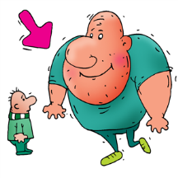 | Huge…stretch arms out as wide as possible. Sounds like ‘you’ in the middle.  Like in the words ‘huge’, ‘cute’ and ‘cube’.
u-e |  | oo. Pretend to play a flute.  Like in the words ‘flute’, ‘June’ and ‘rude’.
sure | 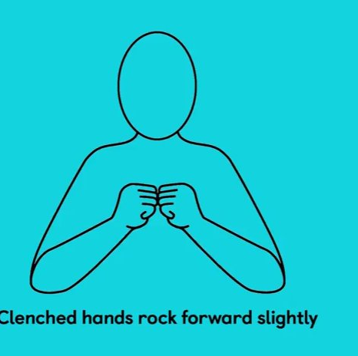 | Like in ‘treasure, ‘measure’. Make a treasure box shape with hands and open it up.

Phase 5 alternative pronunciations. Children need to know that these letters can make more than one sound.
Some are best taught as exceptions through spellings, eg ay = eigh in the word eight.
ea | 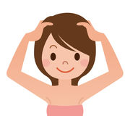 | Short ‘e’ like in ‘head’. Both hands on head.
eigh | 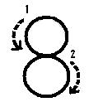 | Like in 8. Make the shape of a number eight.
y |  | Long ‘ee’ sound. Happy smile. Make smile shape with hands.
gn |  | Gnash teeth.
kn |  | Point to knees.
wr | 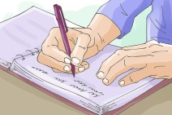 | Writing action.
tch | 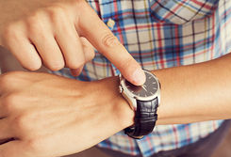 | Point to watch on wrist.
dge |  | Make a bridge shape with hands.
y | 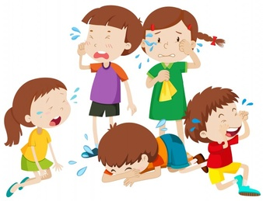 | Like in ‘cry’. Crying action (rub near eyes).
ow | 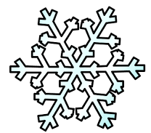 | Make snowflake actions (twinkling hands, moving downwards).
o | 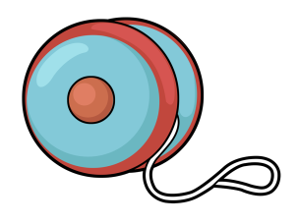 | Long ‘oa’ . YoY o, pretend to do a yo-yo.
o | 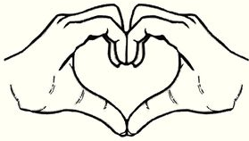 | Making an ‘u’ sound like in love, mother. Make heart shape with both hands.
ore | 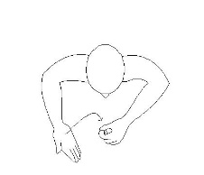 | Makaton sign for ‘more’.
oor | 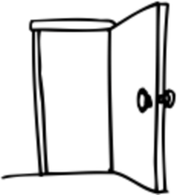 | Use arm/hand to show a door opening.
eer |  | Cheer! Sounds like the word ‘ear’.
are | 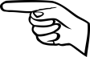 | Make a square shape with both hands. Like in the word ‘square’.
ear | 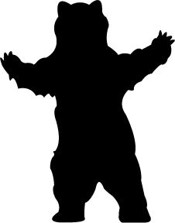 | Hold arms/claws out in a bear stance.
w(a) | 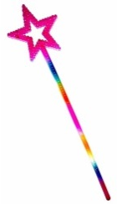 | Wave a wand. Makes a ‘wo’ sound like in the words ‘was’, ‘want’.

