Nursery Home Learning
Week beginning Monday 20th April 2020
All the links can be followed or find the resources on our website (Curriculum/Home Learning Tab)
Literacy | Maths | Physical
Rhyming games:  Day 1: Talk about what rhyme means and do some examples e.g. cat, bat, rat  Day 2: Can you sing some rhyming songs and see if you can spot which words rhyme e.g. hickory dickory dock, hey fiddle fiddle, round and round the garden.  Day 3: Can you read a rhyming book? (Rumble in the Jungle can be found on YouTube)  Day 4: Can you play odd one out, try and find 2 items that rhyme and one that doesn’t fit, can you spot the odd one?  Day 5: Can you take it in turns to say a word that rhymes with hat? | Can you go on a shape hunt?  - What shapes can you see in your home, garden, on a walk, in the sky?  - Can you describe how they look? (round, big, small etc.)  - Can you name any of the shapes you can find?  - Can you have a go at drawing some shapes of your own? | Can you make an obstacle course outside or in the park?  For example:  Hop to the first tree  Skip to the bench  Run to the tree etc.
Discussion time | Wellbeing/Outdoor activity | Phonics
Find somewhere comfy to sit/ lay down.  Talk about this would you rather question, and explain your reasoning why:  Would you rather eat:  - Spider jelly  - Worm cake  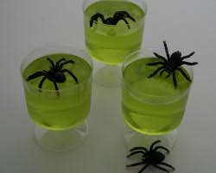  - Fly pie  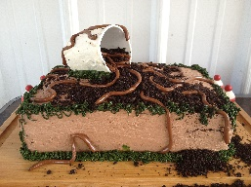  Can you think of your own would you rather question? | Find somewhere comfy to start the activity.  Can you pretend to be some of these animals by doing the Yoga positions? Concentrate on your breathing and relax.  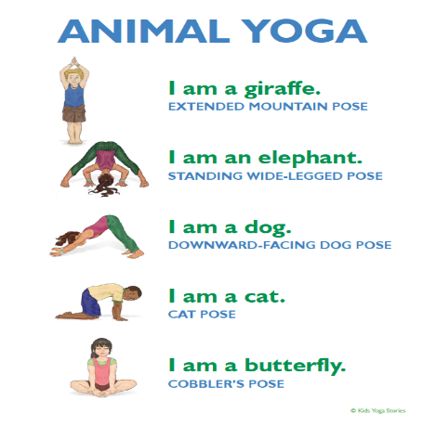 | Can you go on a sound hunt? You could pretend you have giant ears! What sounds do you hear in your home? What sounds do your hear outside? You could draw some pictures for each sound you hear.
 |  | Other Topic
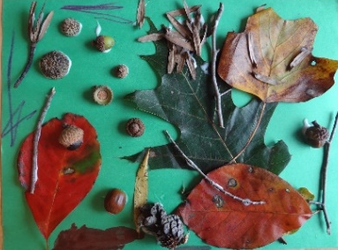
Craft – Can you have a go at making your own nature picture? You can use anything you can find.

