Home Learning Tasks: (Autumn 1: September 2020) ‘Once upon a time’.
Parents: Here are a few suggestions for home-learning. We are delighted to see and share any learning they do at home (please don’t feel you have to stick to this list!).
Ongoing weekly Home-learning:
Reading: It is so important that you read with your child at home. Please focus on the phonics book (see journal for more information) | Maths mat: See the weekly maths mat.  Weekly maths challenge eg counting (you don’t need to write anything down but any repetitive practise is great!) |  | SPaG (spelling, punctuation and grammar) mat.
ENGLISH  - Read traditional stories/Fairy stories, e.g Jack and the Beanstalk, Little Red Riding Hood, The Elves and the Shoemaker.  - Write your own version of a traditional story (change the characters or the ending).  - Write a character description for a character from a traditional tale or fairy story.  - Write a book review about a traditional tale or fairy story.  - Make a traditional story in a shoe box (decorate the shoebox as the setting, make characters/ models/ puppets to tell the story). |  | TOPIC  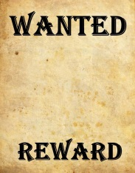  - Make a game based on ‘Once upon a time’. This could be a board game, a card game, a quiz etc.  - Make a wanted poster for a traditional  tale ‘Baddie’.  - Find out about different trees. How did they start off? What are their leaves like?  - Make sure you know when you were born and when your birthday is.  - Find out about you as a baby or toddler. What was your first word? When did you learn to walk? Maybe include some photographs.  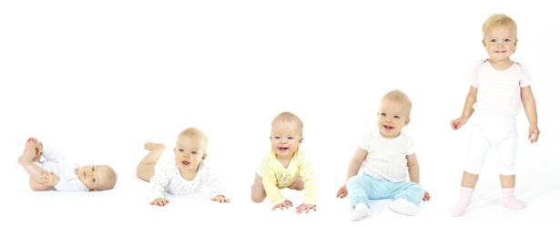  Make a simple timeline to show events in your own personal ‘Once upon a time’ eg holidays, starting school, moving house/class etc.
MATHS
- Practise counting in ones, twos, fives and tens (forwards and backwards) We like this counting to 100 song and it helps to keep us active too! https://www.youtube.com/watch?v=QbHobZOKY5w
- Your child should have their log in details for Education City. There are so many maths games to play to practise skills. There are a variety of games based on ‘Place Value’ that I have assigned to the class.
You can access any game though and don’t have to stick to this list! There are some Year 1 and some Year 2 ones to try. Have fun!

