Home Learning Tasks: (Spring Term 2020) ‘Being Healthy’.
Parents: Here are a few suggestions for homelearning. We are delighted to see and share any learning they do at home (please don’t feel you have to stick to this list!)
ENGLISH  - Read at least 4 times a week (adults please sign the reading journals). How are you getting on reading to your pet?  - Complete the weekly SPaG mat activities  - Find out about how to make healthy snacks/food. Could you follow a recipe?  - Make a ‘Healthy Diary’. Record any healthy food eaten or any exercise done.  - Find out about Florence Nightingale. Write a report or make a booklet.  - Find out about the jobs that nurses do.  - Find out about jobs that people you know do. Write about the job that you would like to do in the future. | TOPIC  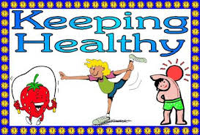  - Make a game based on ‘Being Healthy’. This could be a board game, a card game, a quiz etc.  - Make a poster showing people how we can keep healthy.  - Tell us about any hobbies that help to keep you healthy. This could be a poster, booklet or even a film.  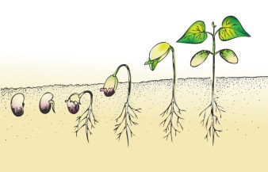  - Plant seeds and watch them grow. Bring any pictures of what you have grown (this might not be until nearer the end of the term).  - Look for plants starting to grow in the garden/out and about. Draw what you see.  - Make a poster reminding people how to wash their hands/clean their teeth to help keep healthy.  - Look on the internet for photographs of germs seen through a microscope. Design your own ‘germ’ character.
MATHS
- Play ‘Snakes on the Brain’ and other games assigned on ‘Education City’ (please ask if you need another copy of the login details)
- Continue to practise the weekly mental and oral aspect (on the back of the SPaG mat)
- Look at mistakes on the Take 5 booklet if not moved up that week
- Measure out ingredients to make a healthy snack
- Draw pictures using 2D shapes

