Support for children, young people and school staff during Coronavirus

With children:
Coronavirus for young children – booklet produced by Manuela Molina
https://www.mindheart.co/descargables
A message from the author
Dear families and educator all over the world,
I have created this short book to support and reassure our children, under the age of 7, regarding the COVID-19. This book is an invitation for families to discuss the full range of emotions arising from the current situation. It is important to point out that this resource does not seek to be a source of scientific information, but rather a tool based on fantasy. My recommendation is to print this material so children can draw on it. Remember that emotions are processed through repetitive play and stories read multiple times. Share COVIBOOK and help ease kiddo's anxiety all over the world.
​
Video, useful for Y3 – Y7 https://www.brainpop.com/health/diseasesinjuriesandconditions/coronavirus/

Talking to children:
Some useful information about what to say to children re Covid-19 from Norway, can be adapted
https://krisepsykologi.no/what-can-we-say-to-children-about-coronavirus/
Advice for adults talking to children about coronavirus from the British Psychological Society
https://www.bps.org.uk/news-and-policy/talking-children-about-coronavirus

Well-being:
BBC mental wellbeing article, Coronavirus: How to protect your mental health https://www.bbc.co.uk/news/health-51873799

Mind guidance Managing our Mental Health and Staying Well during Virus outbreak https://www.mind.org.hk/wp-content/uploads/2020/02/ResponseCoronavirusENG6.2.2020-.pdf

Blog post from Educational Psychology insight around self-care
https://www.epinsight.com/post/managing-stress-self-care-during-the-coronavirus-crisis
Advice for parents
Helping children manage in unsettling times

The Coronavirus outbreak has led to a high degree of worry, uncertainty and concern. The issue has been very present in the news, and all adults and children will have some degree of awareness of events so far, and may have had their lives disrupted.
During these times both children and adults can potentially feel anxious and unsure about their safety. Alongside school, parents can help provide opportunities where feelings can be discussed within a safe context, as well as maintaining a sense of normality, routine and calm. Supporting children will enable them to process and manage their feelings and build resilience.

The following suggestions may be helpful:
- Reassure children that they are safe: Children will need to be reassured regularly they are safe, and that adults will faithfully try to keep them safe.
- Let children know that it is alright to be upset: Tell children all feelings are ok, but it is important to still behave in a polite and respectful way to others.
- Maintain a normal routine: Set up a work/leisure/exercise routine for students at home. Make extra time to listen to what your children need to tell you.
- Place an emphasis on resilience and strengths: Focus on the child’s skills, in terms of their daily life. Help them see they have many strengths to help them cope if feeling anxious or upset.
- Look for opportunities to help others: Acts of benevolence, charity and humanity help to restore positivity about the world.
- Provide opportunities for children to be honest about their feelings: Sharing worries or feelings of upset with other family members reduces a sense of vulnerability and isolation, raises optimism and self-esteem. Checking in with your children to see if they have any worries can help them start these conversations.
- Provide opportunities for physical exercise: Exercise is valuable in developing natural chemicals in the brain to help us cope with feelings such as shock and worry.
- Communicate any concerns with school: If you have any worries or concerns about your child’s emotional behaviour please do let the school know.
- Look after yourself: A time of stress can mean less energy and more potential for illness for you, as well as others. So please take care of yourself.

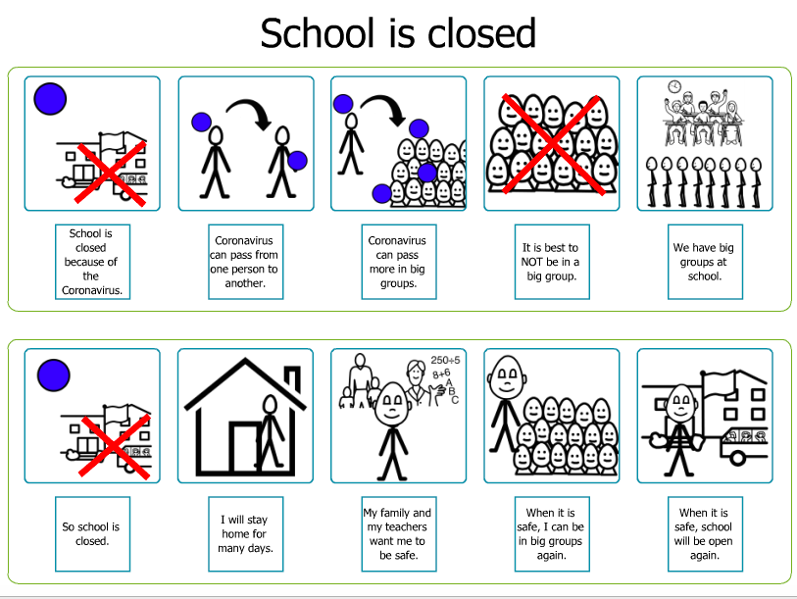

Social story from @ZonesofReg – in case of closure

