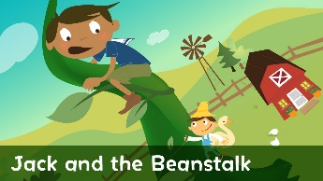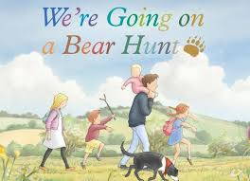**Class Ash Home Learning**

**Autumn 1 – Toys & Once Upon A Time**

This is your home learning menu, please work through these activities with your child. Reception are not obliged to complete large amounts of home learning, so only choose things they are interested in doing with you. There is more of an expectation on Y1 for their home learning, so please complete at least one task from each of the sections.

Please can home learning tasks for this half term be returned to school by

Monday 19th October.

Thank you and enjoy your home learning!

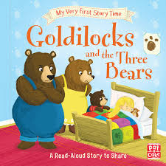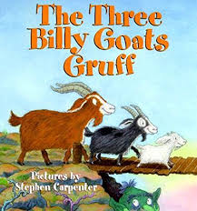

Literacy:

* Can you practise your letter formation using the template?
* Can you make a poster about your favourite toy?
* Can you do a book review for one of your favourite ‘Once upon a time’ stories?

Y1’s - Remember to practise your reading and spellings as much as you can!

Creative / Investigation:

* Can you make an autumn collage?
* Can you investigate your senses by going on a walk and record what you see, smell, hear, feel and taste?
* Can you research the history of the ‘teddy bear’’?

Maths:

* Can you have a go at the addition questions?
* Can you go on a shape hunt and see how many 2D and 3D shapes you can find?
* Can you practise one more using the sheet provided?