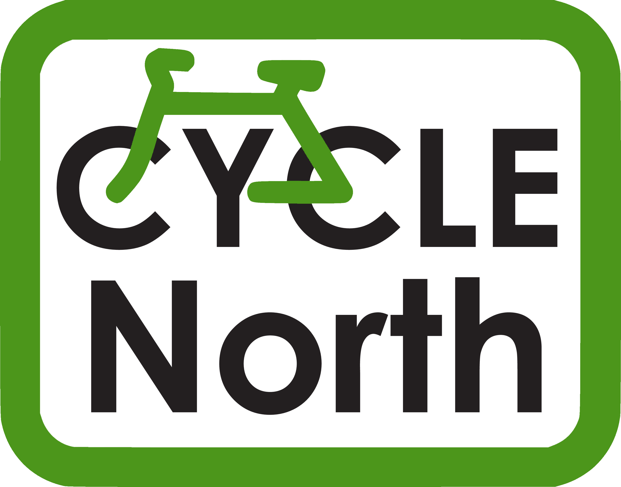
Bikeability Cycle Training

Dear Parent/Guardian

Your School has been chosen as one of a few schools in Sheffield to receive Bikeability Cycle Training. This course seeks to give children the skills and confidence to cycle safely on the road. This fun course starts in the playground and will continue on quiet roads around the school.

In order for your child to take part, you will need to complete the attached consent form and return it to school. The training is free.

We have updated our procedures so that all instructors adhere to the rules surrounding Coronavirus including social distancing procedures.

Ideally your child will use their own bike for the training, but bikes can be loaned to those without. Please tick the box at the end of the form to request a bike and/or helmet loan.

Children need to be able to ride a bike to take part in Bikeability Level 1 and 2. If your child cannot ride a bike, please tick the box at the end of the consent form and we may be able to arrange a slot to teach them during our time in school.

The cycling will continue whatever the weather, so please send your child with warm and waterproof clothing. Gloves are a good idea. We suggest that pupils wear trousers or tracksuit bottoms when training.
The training will take place during school time on:
Monday 9th to Wednesday 11th November.
Your school will tell you which days your child will receive their training.

This course is being run by Cycle North on behalf of Sheffield City Council and the instructors are fully qualified, checked and insured.

Your child will need to have with them, for all their course sessions:
- A bike which is roadworthy and fits properly.
A bike check will be carried out on the first day and any bike which is not roadworthy cannot be used on the course. I’ve attached a bike check form to help you ensure that your child’s bike is in a good condition.
- A cycle helmet (which fits!)
- Warm clothing and a water-proof jacket

Your child will be continuously assessed throughout the course. The training will start with a playground session and the children must reach the required standard in cycle control, in order to proceed to the on-road Level 2 sessions that follow. At the end of the course, all children will receive a certificate that confirms their participation on the course along with a badge.

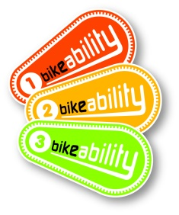
Andrew Crossley (Bikeability Training Manager)
andrew.crossley@cyclenorth.co.uk
Mobile: 07504 282133

Is the bike alright to use?

The cycle training can be done on any sort of bike, as long as it is roadworthy and has both a front and back brake. Please check your bike using the checklist below. If in doubt take it to a bike shop and ask them to check it. Our trainers are not mechanics, but may be able to make minor adjustments on the day. Unfortunately, if your child arrives with a bike that we do not consider safe to use on the roads, your child will not be able to do the training unless you have booked a loan bicycle with us.

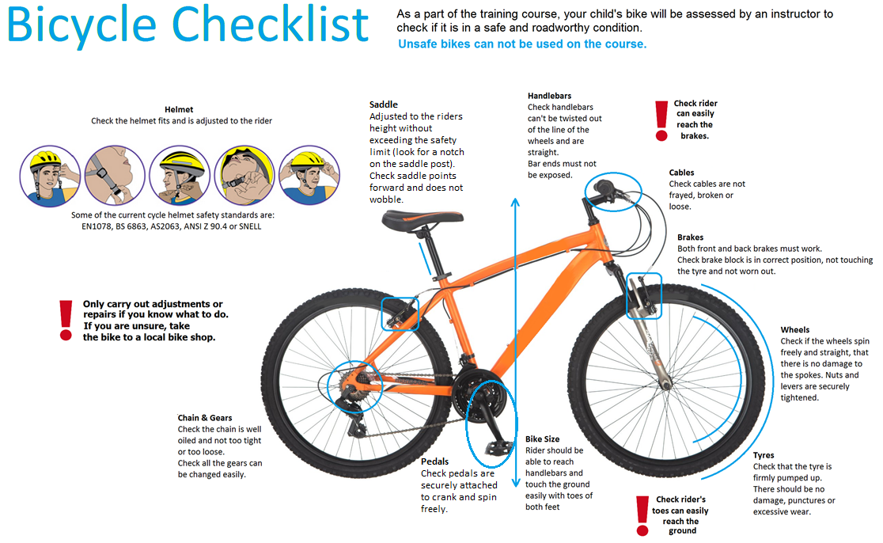

BIKEABILITY CYCLE TRAINING

Parent or Guardian Consent form

Return this whole sheet to your child’s school

Your child’s name: _____________________________________

Class: _____________________________________

Medical Information
Please tell us of any medical condition which we should know about in the box below. For example, poor eyesight, asthma, epilepsy, impaired hearing etc. It is unlikely that a medical condition will prevent your child from receiving training.

Please read and sign the following declaration

I have read and understood the letter to parents.

I will check my child’s cycle to ensure it is roadworthy and I am responsible for keeping it roadworthy throughout the course. I authorise instructors from Cycle North to carry out minor adjustments to the cycle.

My child will be trained on public roads. The training may also include some off-road cycling.

The training will start with a playground session. The children must reach the required standard in cycle control, in order to proceed to the on-road Level 2 sessions that follow.
I accept that Cycle North can refuse to teach my child if their behaviour is deemed to be unsuitable.

I understand that Cycle North will not be liable for any loss or damage to trainees’ cycles and other belongings.

Trainees should not be considered safe to ride in all traffic conditions at the end of the course, but please encourage them to practise and supervise them if possible and their confidence will improve further.

Please tick the box if you wish your child to have loan of a bike helmet □
Please tick the box if you wish your child to have loan of a bike □
Please tick the box if your child can not ride a bike □

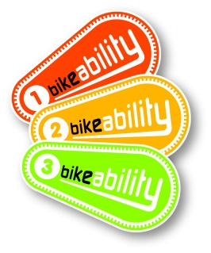
Signed: ________________________

Date: ________________________

