Assessment, Recording & Reporting Policy

Reviewed: February 2019

- Rationale:
We aim for high quality teaching and learning, and the heart of this is effective assessment, underpinned by our growth mindset belief that all pupils can suceed.
We use three main forms of assessment: in-school formative, in-school summative, and national standardised summative assessment.

- Aims:
The aims of assessment are to enable:

- Pupils to demonstrate what they know, understand and can do in their learning
- Teachers to respond accurately to the learning needs of each pupil and, with the contribution of support staff, give ongoing support to enable all pupils to make progress
- Pupils to have an active role in identifying their own learning needs and know how to improve their work
- Parents to support their child’s learning
- Leaders to evaluate and continually improve on the quality of provision for all pupils

- Statutory Requirements:
In order to ensure we are compliant with statutory requirements for assessment; we download and follow the most up-to-date versions of the following documents:
- Early Years Foundation Stage: Assessment and Reporting Arrangements (ARA)
- Key Stage 1: Assessment and Reporting Arrangements (ARA)
- Key Stage 2: Assessment and Reporting Arrangements (ARA)
These documents are all available at www.gov.uk and contain relevant information about assessing pupils – including the administration of SATs.

- Forms of assessment:
Form of assessment | Purpose | Examples
Formative assessment / AfL (Assessment for Learning) | - Ensure learning needs are being met and children are making good progress  - Involve and engage children in planning their own learning | - Sharing learning intentions / success criteria  - Effective questioning  - Ongoing observations  - Self / peer assessment  - Verbal / written feedback  - Setting targets
Summative assessment / AoL (Assessment of Learning) | - Ensure progress is tracked on a regular basis  - Identify patterns / gaps  - Support informative discussions with parents  - Enable smooth transition between classes, key stages and schools  - Help to identify children with SEN | - End of unit tests  - Termly assessments  - Optional SATs  - End of year reports  - Other diagnostic tests
National Standardised Assessment | - Ensure assessments are fair and accurate  - Compare the school to other schools locally and Nationally | - EYFS Profile  - Y1 Phonics Screening  - KS1 SATs  - KS2 SATs

- Learning Frames
To support assessment for learning, we use ‘Learning Frames’ in all subjects. These are presented to children at the start of individual lessons; outlining the learning intention and success criteria (differentiated where appropriate). This is then used for self / peer assessment and for teachers to provide suitable feedback; promoting an ongoing dialogue and involving children in their learning journey. For more information, see our Marking and Feedback Policy.
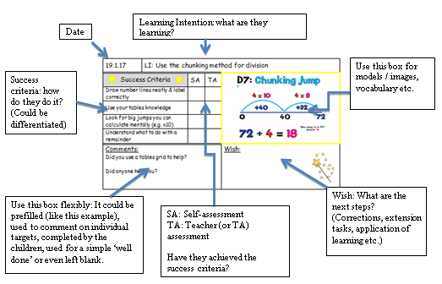

- Target Setting:
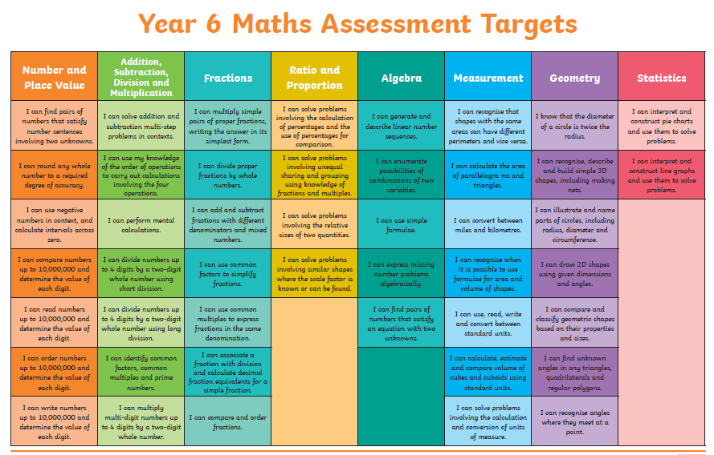
To support children and their parents in identifying their next steps, we share the appropriate year-group overviews. These are displayed in the backs of books and sent home at the beginning of year. Children should be able to discuss their past, present and future learning at an age-appropriate level. These link with the ‘Wishes’ explained earlier and are reported on at the end of the year.
.

- Key Concept Grids (STAT):
In order to track attainment and progress in the core subjects, teachers use the ‘Key Concept Grids’ produced by STAT (School Tracking & Assessment Tools) Sheffield. Objectives from the National Curriculum have been identified as ‘Key Concepts’; i.e. the key milestones / objectives that are needed to ensure progress towards ARE (Age Related Expectations). The statements describe whether a child is starting to learn something (‘Developing’), is at the expected standard for the year group (‘Secure’) or is working at greater depth (‘Extending’). Teachers then use their professional judgement to ascertain a best fit for a child’s current attainment – it is not a case of merely counting ticks.
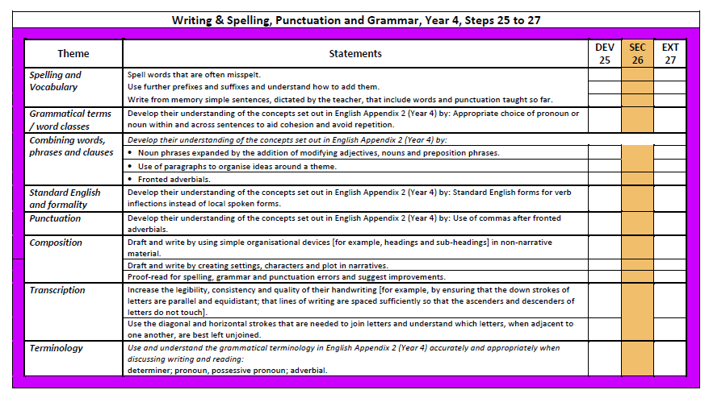

Whilst there are 3 steps against each chronological year, it should be noted that this does not match to the three terms in a year. The expected standard for the end of the year is ‘Secure’; children working at greater depth have exceeded ARE. It is expected that most children will be working within their age-appropriate curriculum; though pupils can be assessed as being on any step at any time regardless of their actual age.
At any point in time, teachers should make their judgements based on what they have actually covered. For example, if a child has exceeded expectations in all lessons by the end of the Autumn term, we would say they are ‘Extending’ – despite having only covered 1/3 of the curriculum.

- Tracking:
At the end of each term, we put our assessment data onto our tracking system, DC Pro (www.dcpro.co.uk). This allows us to analyse performance and identify trends.
Teachers are also expected to identify whether pupils are on track to meet or exceed ARE by the end of the year. This allows us to make accurate predictions for year-end data at any point in time.

- Pupil Progress:
At the start of each academic year, class teachers set year-end targets for individual pupils. These should take previous attainment into account (including end of key stage information) and should be aspirational.
Progress towards these targets is reviewed at our termly ‘Pupil Progress Meetings’. Class teachers meet with the Assessment Leader / Headteacher and discuss the progress being made by each child. Suggestions are made about next steps (including intervention strategies) and advice is sought from the SENDCO where appropriate.

10. Foundation Subject Assessment:
In addition to the core subject assessment detailed above, we also assess children against the foundation subjects. Across the year, children are assessed against at least 4 statements for each subject (6 for Science) using the following criteria:
1 | Working beyond Year __ expectations.
2 | Working at Year __ expectations.
3 | Working towards Year __ expectations
4 | Working at an earlier stage of the curriculum

This information is reported to parents at the end of the academic year. It is then collated by the Assessment Leader and each child is awarded an ‘overall’ grade for each subject. This assists class teachers with planning for foundation subjects and is reviewed regularly. We can also use this data to draw conclusions, such as: 83% of our Y3s are working at or above ARE in History (2017).
11. Reporting to Parents:
We share assessment information with parents in four ways:
- Targets (referred to earlier) are sent home to show what the children are currently working towards.

- Parents’ Evenings: We have 3 Parents’ Evenings across the academic year. In addition to these, we often put on additional ‘information’ meetings (especially in Foundation Stage, Y2 and Y6). Furthermore, we have an open-door policy and parents are welcome to come and discuss their child’s progress at any other time. Our SENCO organises and conducts regular review meetings with the parents of SEN children (see SEN policy for more information).

- Interim Reports: At the end of the Autumn and Spring terms, we send home an ‘Interim Report’ which contains up-to-date assessments for the core subjects and attendance data.

- Annual Reports: At the end of each year, we send home our annual reports. This contains a written comment from the class teacher (200+ words), a comment from the Headteacher, attendance information, a grade for behaviour, grades for individual subjects using the key outlined earlier, a comment on ‘effort’ for each subject and up-to-date targets for the core subjects.

12. Monitoring and Evaluation:
- In order to moderate judgements across classes, we use summative testing towards the end of each term.

- As part of our ongoing book monitoring process, we moderate judgements at staff meetings throughout the year.

- We compare data with other schools in our locality and moderate externally.

- When observing lessons (formally or informally), teachers are given a grade for ‘Assessment’ using the criteria outlined on ‘Lessons Learned’ (www.llo.org.uk). See the table in the appendix for more detail.

13. Appendix: Assessment Overview:

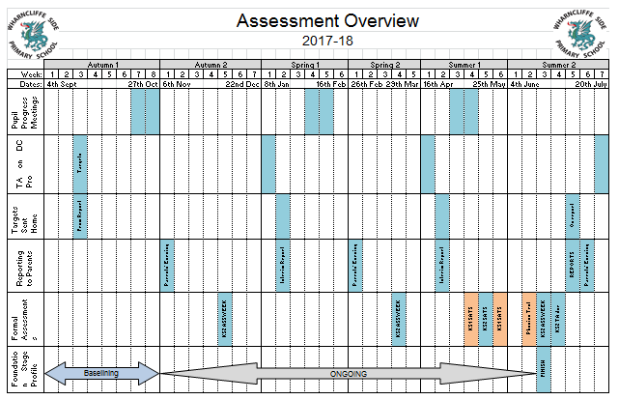

13. Appendix: Assessment Record (informal)
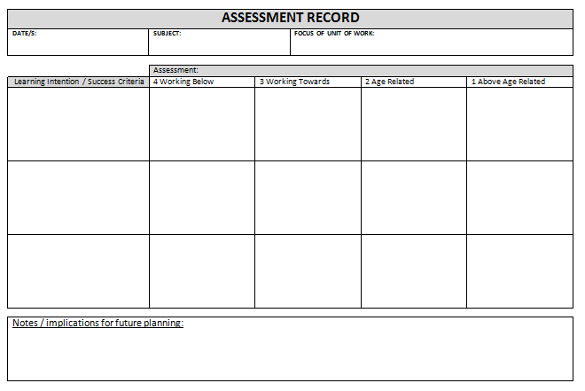

13. Appendix: Criteria for grading lessons
